

FURTHER EDUCATION AND TRAINING CERTIFICATE: INFORMATION TECHNOLOGY: SYSTEMS DEVELOPMENT
ID 78965 LEVEL 4 – CREDITS 165
LEARNER GUIDE
14908
DEMONSTRATE AN UNDERSTANDING OF TESTING IT SYSTEMS AGAINST GIVEN SPECIFICATIONS

Copyright
All rights reserved. The copyright of this document, its previous editions and any annexures thereto, is protected and expressly reserved. No part of this document may be reproduced, stored in a retrievable system, or transmitted, in any form or by any means, electronic, mechanical, photocopying, recording or otherwise without the prior permission.

Learner Guide Introduction

About the Learner Guide… | This Learner Guide provides a comprehensive overview of the Demonstrate an understanding of testing it systems against given specifications, and forms part of a series of Learner Guides that have been developed forFurther Education and Training Certificate: Information Technology: Technical Support ID 78964 Level 4 – 163 Credits. The series of Learner Guides are conceptualized in modular’s format and developed forFurther Education and Training Certificate: Information Technology: Technical Support ID 78964 Level 4 – 163 Credits. They are designed to improve the skills and knowledge of learners, and thus enabling them to effectively and efficiently complete specific tasks. Learners are required to attend training workshops as a group or as specified by their organization. These workshops are presented in modules, and conducted by a qualified facilitator.
Purpose | The purpose of this Learner Guide is to provide learners with the necessary knowledge related to Demonstrate an understanding of testing it systems against given specifications.
Outcomes | People credited with this unit standard are able to:  - Select an appropriate test procedure for the hardware and software  - Apply the test procedure to hardware and software  - Collect and record data from tests
Assessment Criteria | The only way to establish whether a learner is competent and has accomplished the specific outcomes is through an assessment process. Assessment involves collecting and interpreting evidence about the learner’s ability to perform a task. This guide may include assessments in the form of activities, assignments, tasks or projects, as well as workplace practical tasks. Learners are required to perform tasks on the job to collect enough and appropriate evidence for their portfolio of evidence, proof signed by their supervisor that the tasks were performed successfully.
To qualify | To qualify and receive credits towards the learning programme, a registered assessor will conduct an evaluation and assessment of the learner’s portfolio of evidence and competency
Range of Learning | This describes the situation and circumstance in which competence must be demonstrated and the parameters in which learners operate
Responsibility | The responsibility of learning rest with the learner, so:  - Be proactive and ask questions,  - Seek assistance and help from your facilitators, if required.

Learning Unit1
Demonstrate an understanding of testing IT systems against given specifications
UNIT STANDARD NUMBER : 14908
LEVEL ON THE NQF : 4
CREDITS : 6
FIELD : Physical, Mathematical, Computer and Life Sciences
SUB FIELD : Information Technology and Computer Sciences

PURPOSE: | This unit standard is intended:  - To demonstrate fundamental of knowledge of the areas covered  - for those working in, or entering the workplace in the area of Hardware, Infrastructure Maintenance and Support  People credited with this unit standard are able to:  - Select an appropriate test procedure for the hardware and software  - Apply the test procedure to hardware and software  - Collect and record data from tests  The performance of all elements is to a standard that allows for further learning in this area.
LEARNING ASSUMED TO BE IN PLACE:
Open.
The credit value of this unit is based on a person having the prior knowledge and skills to:
- Demonstrate an understanding of fundamental English (at least NQF level 3)
- Demonstrate PC competency skills (End User Computing unit standards up to level 3)

SESSION 1
Select an appropriate test procedure for the IT Systems to be tested.
LEARNING OUTCOMES
- The selection clarifies the purpose of the test and the data required from it.
- The selection identifies any factors that may affect the choice of the test procedure.
- The selection identifies the resources available for the test procedure.
- The selection complies with all relevant regulatory, licensing, contractual and health and safety requirements.

The selection clarifies the purpose of the test and the data required from it.
What the purpose of testing?
There are two fundamental purposes of testing: verifying procurement specificationsand managing risk. First, testing is about verifying that what was specified is what wasdelivered: it verifies that the product (system) meets the functional, performance,design, and implementation requirements identified in the procurement specifications.Second, testing is about managing risk for both the acquiring agency and the system’svendor/developer/integrator.
The testing program is used to identify when the work hasbeen “completed” so that the contract can be closed, the vendor paid, and the systemshifted by the agency into the warranty and maintenance phase of the project.
The purpose of system testing is to ensure that a system meets its specification and any non-functional requirements (such as stability and throughput) that have been agreed with its users.

System testing
System testing of software or hardware is testing conducted on a complete, integrated system to evaluate the system's compliance with its specified requirements. System testing falls within the scope of black box testing, and as such, should require no knowledge of the inner design of the code or logic.
As a rule, system testing takes, as its input, all of the "integrated" software components that have passed integration testing and also the software system itself integrated with any applicable hardware system(s).
The purpose of integration testing is to detect any inconsistencies between the software units that are integrated together (called assemblages) or between any of the assemblages and the hardware. System testing is a more limited type of testing; it seeks to detect defects both within the "inter-assemblages" and also within the system as a whole.

What is involved in a hardware test program?
In general, the hardware test program can be broken into six phases as describedbelow.
- Prototype testing – Prototype testing is generally required for “new” and customproduct development but may also apply to modified product depending on the nature and complexity of the modifications. This tests the electrical, electronic, andoperational conformance during the early stages of product design.
- Design Approval Testing (DAT) – DAT is generally required for final pre-productionproduct testing and occurs after the prototype testing. The DAT should fully demonstrate that the ITS device conforms to all of the requirements of the specifications.
- Factory Acceptance Testing (FAT) – FAT is typically the final phase of vendorinspection and testing that is performed prior to shipment to the installation site. TheFAT should demonstrate conformance to the specifications in terms of functionality,serviceability, performance and construction (including materials).
- Site Testing – Site testing includes pre-installation testing, initial site acceptancetesting and site integration testing. This tests for damage that may have occurredduring shipment, demonstrates that the device has been properly installed and thatall mechanical and electrical interfaces comply with requirements and other installedequipment at the location, and verifies the device has been integrated with the overall central system.
- Burn-In and Observation Period Testing – A burn-in is normally a 30 to 60 dayperiod that a new devise is operated and monitored for proper operation. If it failsduring this period, repairs or replacements are made and the test resumes. Theclock may start over at day one, or it may resume at the day count the device failed.An observation period test normally begins after successful completion of the final(acceptance) test and is similar to the burn-in test except it applies to the entire system.
- Final Acceptance Testing – Final acceptance testing is the verification that all ofthe purchased units are functioning according to the procurement specifications afteran extended period of operation. The procurement specifications should describethe time frames and requirements for final acceptance. In general, final acceptancerequires that all devices be fully operational and that all deliverables (e.g., documentation, training) have been completed.

What is involved in a software test program?
In general, the software test program can be broken into three phases as describedbelow.
- Design Reviews – There are two major design reviews: (1) the preliminary designreview conducted after completion and submission of the high-level design documents and (2) the detailed design (or critical) review conducted after submission ofthe detailed design documents.
- Development Testing – For software, development testing includes prototypetesting, unit testing, and software build integration testing. This testing is normallyconducted at the software developer’s facility.
- Site Testing – Site testing includes hardware/software integration testing, subsystem testing, and system testing. Some integration testing can be conducted in adevelopment environment that has been augmented to include representative system hardware elements (an integration facility) but must be completed at the finalinstallation site (i.e., the transportation management center) with communicationsconnectivity to the field devices.

The selection identifies any factors that may affect the choice of the test procedure.

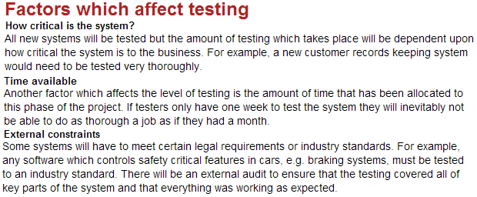

Here are some of the factors to consider, which can affect the test effort:
- While good project documentation is a positive factor, it’s also true that having to produce detailed documentation, such as meticulously specified test cases, results in delays. During test execution, having to maintain such detailed documentation requires lots of effort, as does working with fragile test data that must be maintained or restored frequently during testing.
- Increasing the size of the product leads to increases in the size of the project and the project team. Increases in the project and project team increases the difficulty of predicting and managing them. This leads to the disproportionate rate of collapse of large projects.
- The life cycle itself is an influential process factor, as the V-model tends to be more fragile in the face of late change while incremental models tend to have high regression testing costs.
- Process maturity, including test process maturity, is another factor, especially the implication that mature processes involve carefully managing change in the middle and end of the project, which reduces test execution cost.
- Time pressure is another factor to be considered. Pressure should not be an excuse to take unwarranted risks. However, it is a reason to make careful, considered decisions and to plan and re-plan intelligently throughout the process.
- People execute the process, and people factors are as important or more important than any other. Important people factors include the skills of the individuals and the team as a whole, and the alignment of those skills with the project’s needs. It is true that there are many troubling things about a project but an excellent team can often make good things happen on the project and in testing.
- Since a project team is a team, solid relationships, reliable execution of agreed-upon commitments and responsibilities and a determination to work together towards a common goal are important. This is especially important for testing, where so much of what we test, use, and produce either comes from, relies upon or goes to people outside the testing group. Because of the importance of trusting relationships and the lengthy learning curves involved in software and system engineering, the stability of the project team is an important people factor, too.
- The test results themselves are important in the total amount of test effort during test execution. The delivery of good-quality software at the start of test execution and quick, solid defect fixes during test execution prevents delays in the test execution process. A defect, once identified, should not have to go through multiple cycles of fix/retest/re-open, at least not if the initial estimate is going to be held to.

The selection identifies the resources available for the test procedure.
Resource Types
In system testing, various operations are necessary for detecting failures. In configuration testing, operations such as software and/or hardware installation, and change of configuration (such as preferences or property) can produce failures. In stress testing, operations such as reading huge data files and heavily loaded use of the network can produce failures. Considering the various operations to be done in a system test, resources can be classified into four types: module, data, storage, and semaphore.

Each type of resource has the following specific attributes. A change of an attribute causes a change in the behavior of the SUT.
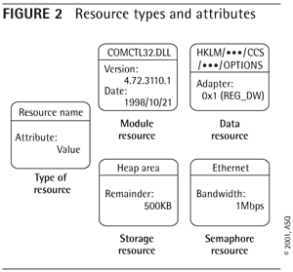
- Module resource: DLL and so on, which have attributes such as version, date, and so on
- Data resource: Such as registry and file, which have attributes that refer to content
- Storage resource: Buffer, memory, disk, and so on, which have attributes such as size, capacity, and so on
- Semaphore resource: Such as Ethernet and DB record, which have attributes such as collision, lock, and so on Figure 2 shows an example of each type of resource and its attributes.
It should be noted that a change in an attribute of a module resource such as "version" and "date" is not a change in the attribute itself, but a change in the attribute as a result of the replacement of the resource. The "date/time" of a DLL, for example, should not be changed by modifying the information in directory entries, but by replacing it with a DLL created on a different date and time.
The Resource Allocation Process
First we properly defined the new scenario and problems we faced. We noticed that the differences among the projects were related to the effort, not to the technology or to any other project characteristic. And the major problem was estimating the testing team size and the testing project length.
We decided that the projects under test would be classified by effort. Then, we created the following classifications:
- Projects up to seven PMs: The testing team would apply the "Free Allocation" system.
- Projects from eight to twelve PMs: The testing team would apply the "Intermediate Allocation" system.
- Projects more than twelve PMs: The testing team would apply the "Full Allocation" system.
Based on this classification, we wrote the "Resource Allocation Process" containing a new approach to our testing methodology. The systems test group believes that the questions will be answered when applying the Resource Allocation Process to projects. That means cost-sensitive projects still can benefit from an independent testing team involved throughout the project lifecycle.
The process was presented to all groups (development, sustaining, and documentation) at my organization and the development managers decided it should be applied in the next projects.

The selection complies with all relevant regulatory, licensing, contractual and health and safety requirements.
Software developers often distinguish acceptance testing by the system provider from acceptance testing by the customer (the user or client) prior to accepting transfer of ownership. In the case of software, acceptance testing performed by the customer is known as user acceptance testing (UAT), end-user testing, site (acceptance) testing, or field (acceptance) testing.
Self-regulatory organizations, certain alternative trading systems, plan processors, and certain exempt clearing agencies would be required to carefully design, develop, test, maintain, and surveil systems that are integral to their operations. The proposed rules would require them to ensure their core technology meets certain standards, conduct business continuity testing, and provide certain notifications in the event of systems disruptions and other events.
Software system safety
In software engineering, software system safety optimizes system safety in the design, development, use, and maintenance of software systems and their integration with safety-critical hardware systems in an operational environment.
What a safety-critical software system is
- A safety-critical software systemis a computersystemwhosefailureormalfunctionmayseverelyharmpeople'slives, environmentorequipment.
- Somefields and examples:
  - Medicine (patientmonitors)
  - Nuclear engineering (nuclear powerstation control)
  - Transport (railwaysystems, cars anti-lockbrakes)
  - Aviation (control systems: fly-by-wire)
  - Aerospace (NASA spaceshuttle)
  - Civil engineering (calculatestructures)
  - Militarydevices
  - Etc.

Testing safety-critical software systems
- Basic idea: Identifyhazards as early as possible in thedevelopmentlife-cycle and try to reduce them as much as possibletoanacceptablelevel.
- Remember: Always test software againstspecifications!
- Independentverificationrequired
- If formal methodshavebeenusedthen formal mathematicalproofis a verificationactivity.
- Alreadyknowntechniquesusedfortypicalsystems
  - White box testing
  - Black box testing
  - Reviews
  - Staticanalysis
  - Dynamicanalysis and coverage
- Specificprocedures and techniquesfrom safety engineering:
  - Probabilisticriskassessment (PRA)
  - Failuremodes and effectsanalysis (FMEA)
  - Faulttreesanalysis (FTA)
  - Failuremode, effects and criticalityanalysis (FMECA)
  - Hazard and operatibilityanalysis (HAZOP)
  - Hazard and riskanalysis
  - Cause and effectdiagrams (akafishbonediagramsor Ishikawa diagrams)

SESSION 2
Apply the test procedure to the IT Systems to be tested.
LEARNING OUTCOMES
- The application ensures correct preparation of the test procedure.
- The application tests the hardware using the selected test procedure.
- The application tests the software using the selected test procedure.
- The application ensures that all performance parameters and operational requirements are tested.
- The application identifies any problems with the test procedure and takes appropriate action.
- The application complies with all relevant regulatory, licensing, contractual and health and safety requirements.

Apply the test procedure to the IT Systems to be tested
Test Approach
Test Approach Description
The general methodology/approach for PeopleSoft Upgrade System Testing at ITS will involve the following steps:
- Both a minor and major upgrade will test all the critical business functions at least once.
- Confirm the key contact list (lead matrix) is updated.
- Review reports needed for tracking System Testing, update if necessary.
- Review the issue management process, update if necessary.
- Confirm the test conditions, cycles, and plans based on functional requirements are updated. Plans should include conditions for testing users’ security access.
- Ensure test conditions are grouped by business process. There should be a separate test plan that follows a transaction through the entire system versus just at the entry or exit point. (End-to-end test plan).
- Confirm the interface listing worksheet is updated. (For HE - This worksheet lists all external interfaces, which are files that are received or sent, outside of HRMS and SA.) This should include all database links and the access granted (i.e. Read Only, Read/Write, etc).
- Confirm the critical path business processes are updated.
- Identify any risks that may jeopardize the schedule completion.
- Review with Central Offices; obtain Acknowledgment of System Test Plan(s).
For each Phase of System Testing:
- Execute the test condition.
- Check the output against the expected results.
- Evaluate and document any unexpected results. Utilize testing incidents database.
- Make sure that any required corrections are migrated and re-tested.
- Make sure that final testing components (conditions, input, and expected results) are accurate, complete and documented in such a way to make them repeatable and reusable.
- Review and obtain Acknowledgment of System Test results where appropriate (i.e. new functionality).

Test Phases
There are separate phases of testing which are designated on the timeline within the overall System Test phase. Each phase may include several types of testing. The level of testing for an upgrade is more condensed and may not be as time-consuming as for an implementation. When possible, some of these phases may be done concurrently.
The following is a list of the test phases included in the overall System Test timeframe. However, some of these phases are not covered in detail in this document. There are separate Approach documents for those noted. The types of testing listed in SIT1 and SIT2 are described in the table in the following section.
- System Integration Testing I (SIT1)
This phase includes integration, system, user testing, security, some end-to-end, and regression test types. All RTP conditions with a criticality of A and those with a B and a High or Medium level of change will be tested. Refer to the Upgrade Prioritization Approach Document for details on the RTP prioritization. The testers may include Developers, CPU Business Analysts, ITS Help Desk, Business Process Owners and End Users.
- System Integration Testing II (SIT2)
This phase includes regression testing (all failed SIT1 conditions), end to end, batch, system, integration, and user testing. All RTP conditions that are Low B’s and C’s will be tested, per module discretion. Refer to the Upgrade Prioritization Approach Document for details on the RTP prioritization. The testers may include Developers, CPU Business Analysts, ITS Help Desk, Business Process Owners, and End-Users. Note: There is a separate Approach document for Batch testing.
- Parallel Testing
This phase validates all processes work together to support the business functions to ensure successful payroll runs. There is a separate Approach document for this testing effort.
- Load Testing
This phase validates that critical functions will meet production performance requirements during peak transaction volumes.
There is a separate Approach document for this testing effort.
- Model Office
This phase enables end-users an opportunity to log into the system, perform their typical tasks on the new system, verify their security access, validate their procedures and get comfortable with the new system. This phase is scheduled after the hard-freeze and if additional defects are found during this phase, migrations will require additional levels of sign-offs. Participation in this phase is at the discretion of each module. There is a separate Approach document for this testing effort.
- Infrastructure/Gateway Testing
There is a separate Approach document for this testing effort.

Testing Type Descriptions
The following is a list of test types that will be performed during SIT1 and SIT2:
Test Type | Focus | System Test Phase
Integration Testing | Testing to find errors in complete functions and processes within and between units. Ensure everything has been linked together correctly. | SIT1 & SIT2
System Testing | Validate that the system functionality performs as specified. Functional requirements define how the system should perform. | SIT1 & SIT2
End-to-End Testing | Validate a transaction through the entire system, not just at entry and exit points. This means a transaction is followed throughout the various modules it may touch. Must be coordinated. | SIT1 & SIT2
Regression Testing | Ensures that the application doesn’t negatively impact previously migrated objects/modules. Re-tests the application to ensure that a fix did not cause another portion to break that was previously working. This is done as objects are migrated to fix errors. | SIT1 & SIT2
Security Testing | Eliminates security accessibility errors. | SIT1 & SIT2
User Testing | Same focus as Integration and System Testing (executing RTP conditions), performed by Users. Also, validates production-ready and data integrity. Note: There is no separate User Testing “phase” – how users are incorporated into the overall testing effort may vary by module. This is the opportunity for users to validate functionality prior to the hard freeze. | SIT1 &/or SIT2 – per module discretion

SESSION 3
Collect and record data from tests.
LEARNING OUTCOMES
- The recording ensures that the required data was produced.
- The recording ensures that the data was correctly collected.
- The recording ensures that the data are sufficient to meet the purpose of the test.
- The recording identifies any problems with the collection of data and takes appropriate action.
- The results are recorded by using an appropriate information system.

Collect and record data from tests
Setting Up Machines and Collecting Diagnostic Information Using Test Settings
You can use Test settings in Microsoft Test Manager and Visual Studio to collect extra data when you run your tests. For example, you might want to make a video recording as you run your test. There are diagnostic data adapters to:
- Collect each UI action step in text format
- Record each UI action for playing back
- Collect system information
- Collect event log data
- Collect IntelliTrace data to help isolate non-reproducible bugs
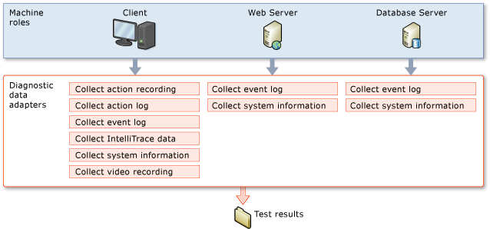
Diagnostic data adapters can also be used to change the behavior of a test machine. For example, with a test setting in Visual Studio, you can emulate various network topology bottlenecks to evaluate the performance of your team’s application.
Using test settings with Microsoft Test Manager
With Microsoft Test Manager, you configure a test plan to run your tests. A test plan can have two test settings:
- Manual runs
- Automated runs
You create these test settings using the Properties page of the test plan in Microsoft Test Manager.
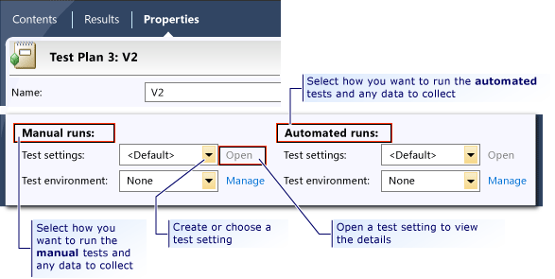
You can configure both of these test settings to use a lab environment which can emulate a single machine, or multiple machine roles. The test setting includes separate configuration settings for the types of data to collect for each machine role using diagnostic data adapters.
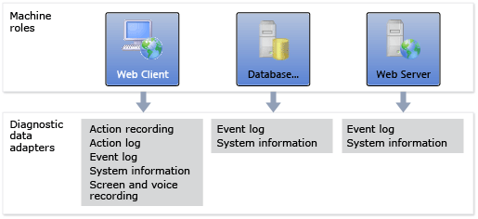
Lab environments
A lab environment is a collection of virtual and physical machines that you can use to develop and test applications. A lab environment can contain multiple machine roles needed to test multi-tiered applications, such as workstations, web servers, and database servers. You can create and manage lab environments and run tests in a lab environment using Microsoft Test Manager. When you run your tests using a lab environment, the test will collect data, or affect the behavior of the machine for each specific machine role that you configured in your test settings. In addition, you can use a build-deploy-test workflow with your lab environment to automate the process of building, deploying, and running automated tests on your application.
The following illustration shows examples of test settings and environments for a test plan.
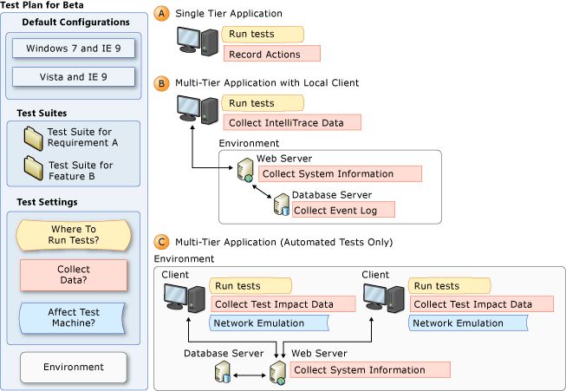
The following illustration shows how you define the set of machine roles for your test settings. You can then select a lab environment that has computers or virtual machines that are assigned to each machine role to use when you run your tests. You can select any lab environment that includes at least the set of machine roles that are defined in your test settings. The lab environment may include other machine roles that are not specified in your test settings, as shown in the following illustration.

Using test settings with Visual Studio
To run your unit, coded UI, web performance, or load tests by using Visual Studio, you can add, configure and select the test settings to use when you run your tests. To run your tests, collect data, or affect a test machine remotely, you must specify a test controller to use in your test settings. The test controller will have agents that can be used for each role in your test settings.

Setting Up Test Machines to Run Tests or Collect Data
Using Visual Studio 2012, you can run your tests and also collect data and diagnostics when you run your tests. You use test settings to specify the data and diagnostics that you want to collect. You can even select diagnostic data adapters that affect the way that your test machine performs. For example, you might want to create a video recording of your desktop while you run your test, or collect system information about your Web server. Additionally, you might want to emulate a slow network to impose a bottleneck on the system.
To run tests remotely on multiple machines, or collect data and diagnostics remotely you must use a test controller and test agents. The test controller runs as a service and assigns tests to a test agent to run. In addition it can tell the test agent what data or diagnostics need to be collected. You can manage the test controller and agents by using Visual Studio, or if you register the test controller with Team Foundation Server, then you can manage the controller and agents by using Microsoft Test Manager.
If you have a distributed application, you define a role for each computer to use to run tests or collect data. For example, if you have an application that consists of a Web server, a database server, and a desktop client, you would define one role for each of these. The desktop client can run the tests and collect data locally, and the other roles can collect any data that you require on the machine that you assign to that role. You can also assign multiple machines to the same role.
If you are using Microsoft Test Manager, you create an environment for this set of roles. An environment is a collection of computers in which each computer has an assigned role.
The following sections of this topic provide more information about the ways to run tests and collect data, based on the type of tests that you run and whether you want to use an environment:
Manual Tests
It is recommended that you run your manual tests on a local machine that is not part of the environment. You can collect data or affect a test machine for your manual tests in the following ways:
- Collect data on the local machine using default test settings
- Collect data on a local machine specifying the data to collect
- Collect data on local and remote tiers of your application
Automated Tests
You can run tests either by using Microsoft Test Manager or by using Visual Studio 2012.
If you plan to run your automated tests by using Microsoft Test Manager, you must use a lab environment that contains a set of roles to run your tests from your test plan. You must create a test controller that is registered with your team project in Team Foundation Server. However, Microsoft Test Manager will set up the test agent in each machine in the environment.
If you plan to run automated tests by using Visual Studio, you can just run your automated tests on your local machine and use test settings to collect data locally. If you want to collect data or affect the test machine for specific parts of a multitier application, you can select a test controller and test agents and add roles to use in your test settings. You should not register the test controller with Team Foundation Server. However, you must set up a test agent in each machine on which you plan to initiate tests or collect test data.
The following illustration shows a test controller and test agents that are installed on a machine for each role in an application under test and the tasks that the test agent can perform. The test controller manages the test agents that are registered to it.

Important
If you want to use a test controller as part of an environment by using Microsoft Test Manager, you must register it with Team Foundation Server, as shown in the following illustration. However, if you want to use a test controller from Visual Studio, do not register the test controller with Team Foundation Server.
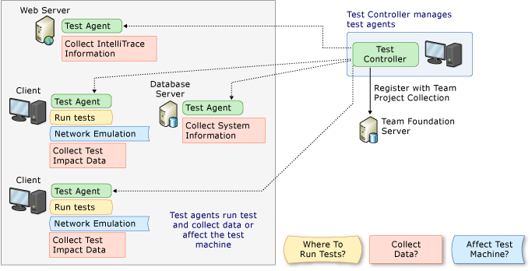
Caution
The test agents and test controllers can be installed in different domains if your testing setup requires it.

Environments
If you use Microsoft Test Manager to conduct your tests, you create lab environments on which to run the tests. There are two kinds of environments: standard and SCVMM environments. A standard environment can use physical computers or virtual machines, and the virtual machines can run on any virtualization framework. An SCVMM environment uses only virtual machines that are managed by System Center Virtual Machine Manager (SCVMM).
Microsoft Test Manager can be used to set up both kinds of environment. In the case an SCVMM environment, you can stop and start environments, store environments in a library, and create multiple copies of them.
In both cases, you assign roles to each machine in the environment. For example, typical roles are Web Server and Desktop Client. The role names are used by your test workflow to determine what software and tests to deploy on each machine.
Test Manager inserts a test agent on each computer, which enables the test controller to deploy software, run tests, and collect test results.

SESSION 4
Prepare the testing to ensure the given specifications will be addressed.
LEARNING OUTCOMES
- The preparation ensures a plan is prepared for the testing in line with the given specifications.
- The preparation ensures the plan specifies what needs to be testing.
- The preparation documents the test scenarios and test data to be used for the test.
- The preparation documents the outcomes expected for each of the scenarios prepared.

Prepare the testing to ensure the given specifications will be addressed
Preparing for System Integration Testing
Planning and preparation is crucial for functional testing success, especially at the system-integration level. Planning and preparation requirements fall into three general categories:
- Testing Hierarchy Initiating a test at a system level when the components are not ready can be frustrating at best and disastrous in some cases. The testing plan must be structured in a manner that builds from the simple to the complex and from the utility systems to the end-user systems.
- Climate Interactions By nature, buildings and their systems are designed to create a controlled environment, isolated from the local climate. To do this, the systems need to function over the entire range of conditions that will be encountered, and a major goal of integrated operation testing is to verify that contingency. Thus, the testing plan must consider the juxtaposition of the commissioning and start-up schedule with the seasons to anticipate and plan for deferred testing where necessary and to protect the building and untested equipment that is coming on line from damage due to inappropriate operation for the current climate conditions.
- Operating Environment Compressed schedules and phased occupancy are becoming the rule in modern construction. These contingencies frequently force phased start-ups of partially complete systems to serve portions of a building that will become occupied and fully operational before the fabrication of the system is complete. In addition, the need for a semi-controlled environment to facilitate the installation of finishes can create intense pressure to use the partially complete HVAC systems for temporary heating and cooling, a high-risk undertaking in many circumstances. Retro commissioning projects, by nature, are challenged with testing machinery that is serving an operating facility without disrupting operations. Thus, it is essential that the test plan take these issues into account and include contingencies for dealing with them.

Test Documentation
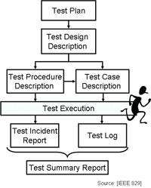
Test documentation is the complete suite of artifacts that describe test planning, test design, test execution, test results and conclusions drawn from the testing activity. As testing activities typically consume 30% to 50% of project effort, testing represents a project within a project. Testing activities must therefore be fully documented to support resource allocation, monitoring and control. This page identifies the types of documents you need to set up and run your test program and summarises their content.
The Test Documentation Tree
Tests must be planned and documented to ensure that test coverage is systematic and complete.

